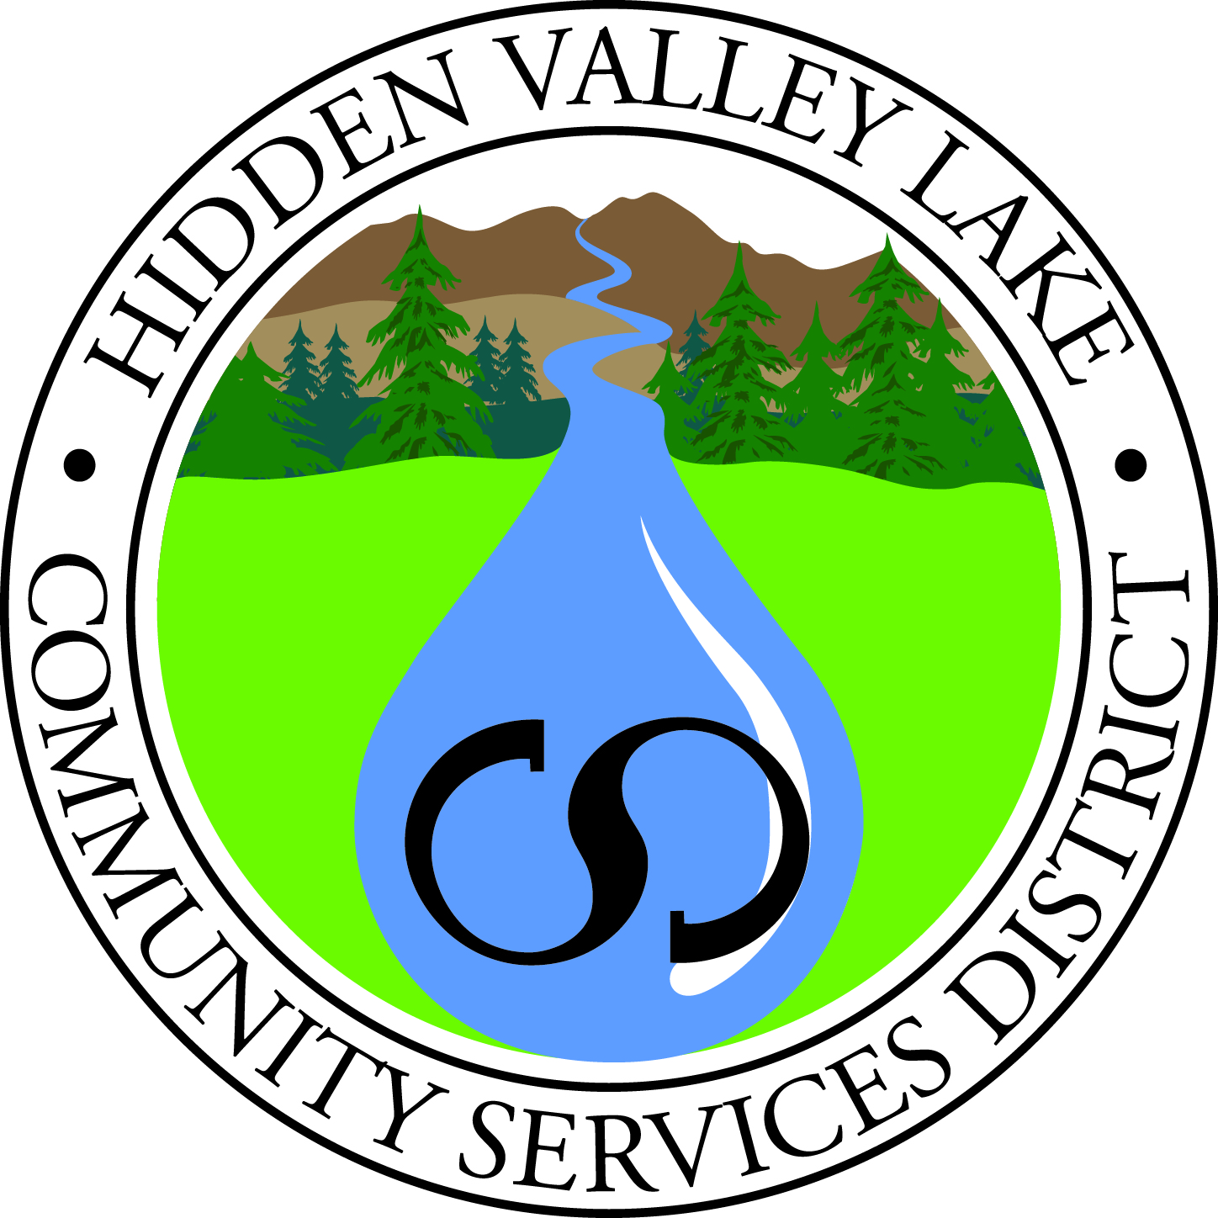
Hidden Valley Lake Community Services District
WORKSHOP

DATE: November 15, 2017
TIME: 11:00 a.m.
PLACE: Hidden Valley Lake CSD
Administration Office, Boardroom
19400 Hartmann Road
Hidden Valley Lake, CA

1) CALL TO ORDER
2) PLEDGE OF ALLEGIANCE
3) ROLL CALL
4) APPROVAL OF AGENDA

5) Presentation by Dennis Timoney and Board Discussion – Board Self Evaluation and Ethics Review

8) PUBLIC COMMENT

9) BOARD MEMBER COMMENT

10) ADJOURNMENT

Public records are available upon request. Board Packets are posted on our website at www.hvlcsd.org/meetings. Click on the “Board Packet” link on the Agenda tab.

In compliance to the Americans with Disabilities Act, if you need special accommodations to participate in or attend the meeting please contact the District Office at 987-9201 at least 48 hours prior to the scheduled meeting.

Public shall be given the opportunity to comment on each agenda item before the Governing Board acts on that item, G.C. 54953.3. All other comments will be taken under Public Comment.

